* **Motor Input:**
* Power: 4.5 KW/ 6 HP
* Conti. Torque/ Rated Torque: 10.3 Nm
* Peak Torque/ Max Torque: 38 Nm
* Nmax: 4500 RPM
* **Car Weight:** 275 Kg
* **Car Wheel Radius:** 11.5” = 0.2921 m
* **For Torque Required:**

F = Rolling resistance + Gradient resistance + Air resistance + Acceleration resistance

F = FR + FST + FL + Fa

m = 275 Kg

g = 9.81 m/s­2

=

=0.85

Rolling resistance coefficient = 0.21

$ρ$ = density of air = 1.122 Kg/m3

V = Expected Velocity = 13.889 m/s ($∵$ 50 Kmph)

A = Projected frontal area = 0.8 m2 (Full firewall area covered by sheet)

Cd = Drag Coefficient = 0.44

La= 40 inches

Hg=27 inches

R dym = 0.29(from table given below)

λ = Rotational inertia coefficient which represents proportion of total mass that is rotary

a = Acceleration at constant speed V

FOR A REAR WHEEL DRIVE FOLLOWING EQAUTIONS WERE DERIVED:

Maximum Tractive Force Required to move our car at an angle alpha

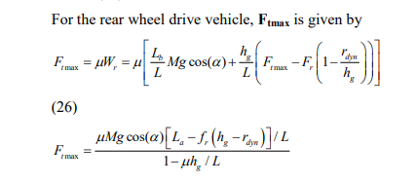

Ftmax=2096.33 at alpha=0

ROLLING RESISTANCE: 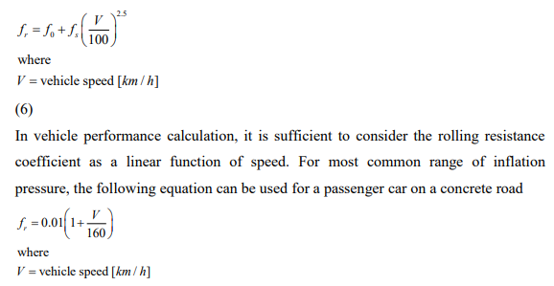

Ft=0.21(calculated)

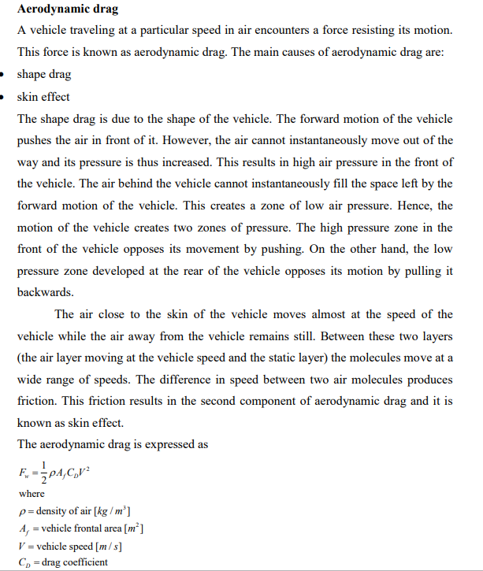

Aerodynamic drag = 525.251N

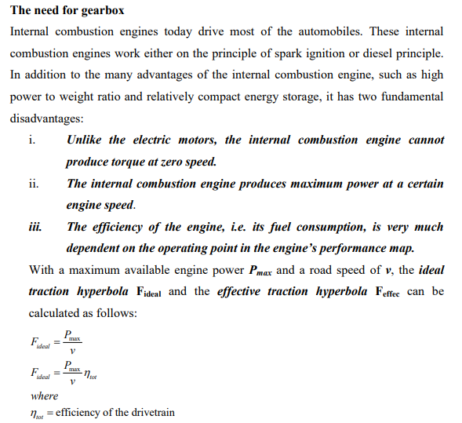

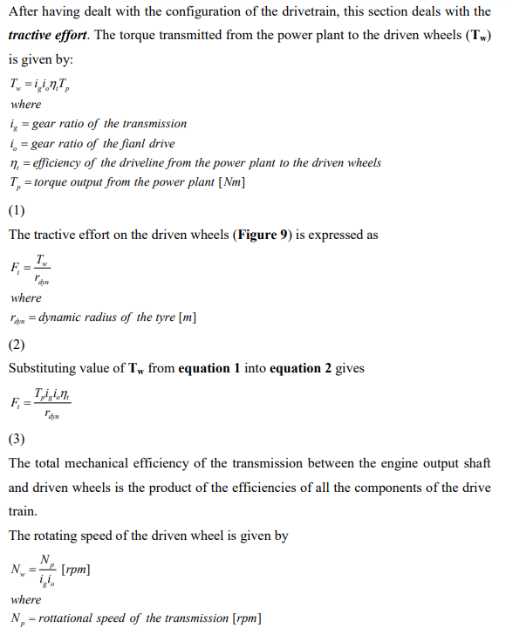

**When gear ratio of transmission is taken as 10 and final drive as 2 and hence overall gear ratio is taken as 20. Total tractive effort =2227.586N**

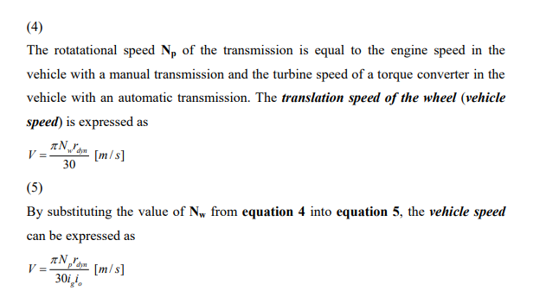

From this above literature on velocity we can comment the max speed of the car is 49.178 km/hr

Also, care has been taken in calculating Velocity as for maintaining torque x speed = constant we have to multiply the whole velocity expression x 2 because we have divided the torque(for each wheel torque conferred by chokshi) by 2 so to maintain the proportinality we have to do it.

Why I have taken this equation only the reason is given below

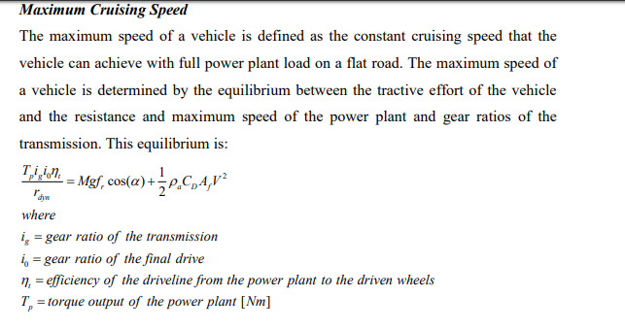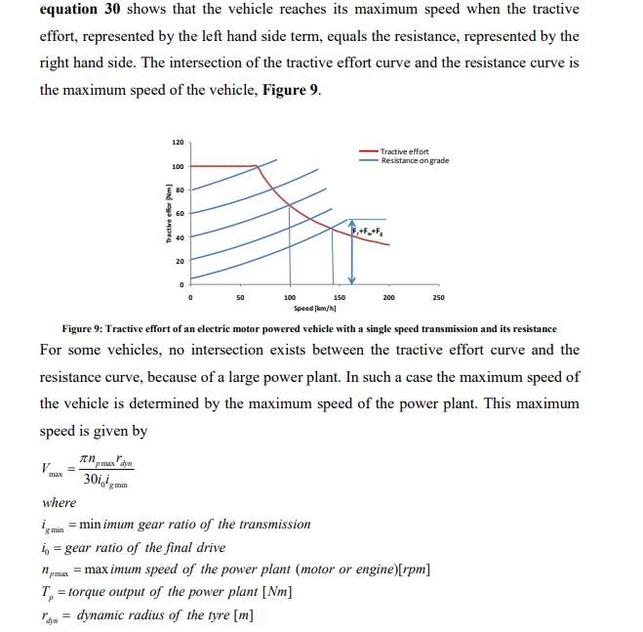

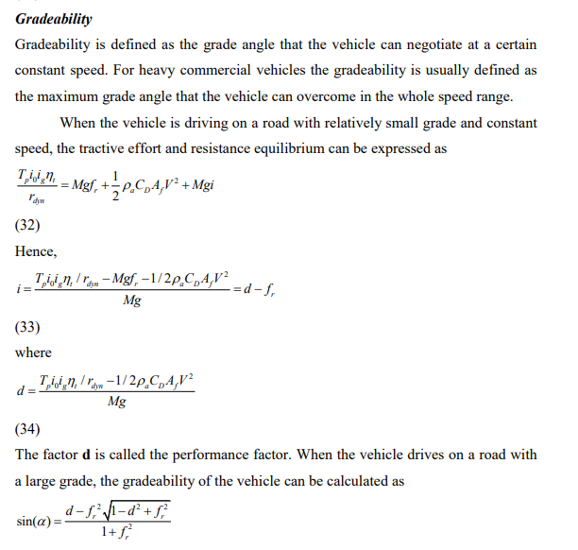

From above we have calculated performance factor (d):0.631

Grade angle: 34.778

Gradeability:69.778%

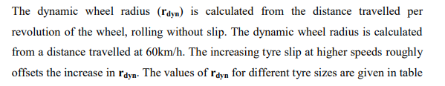 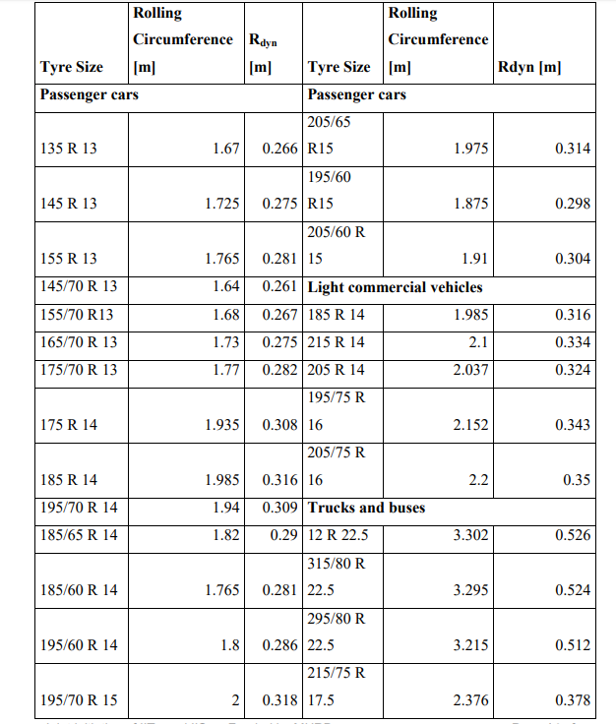

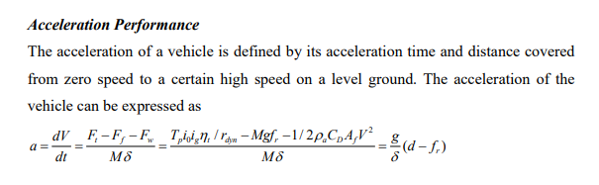

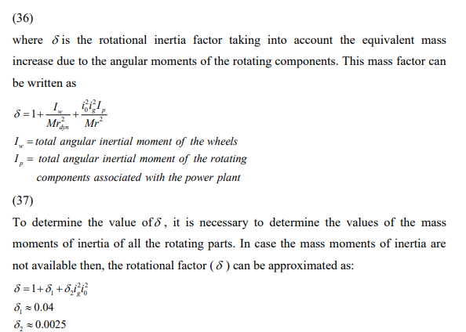

Acceleration:3.75m/s^2